To:Prof. Reichart

From:Philipp Gaveriaux

Date: 26.11.2018

**Report about Tourism**

The aim of this report is to describe trends and developments in tourism, analyse the positive and negative aspects and recommend measures against pollution and destruction.

General background

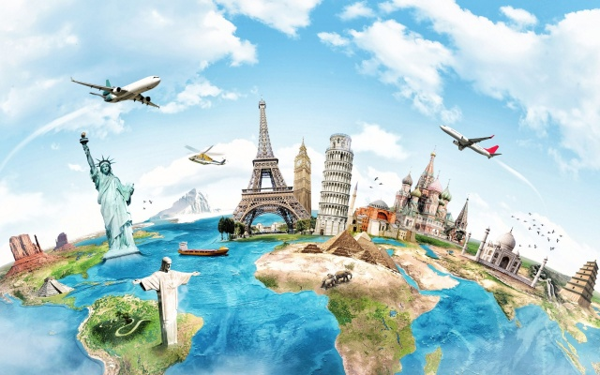

People travel to explore a new culture, to relax, to do an activity (such as skiing) and finally to visit friends or family. Travel & tourism generates 10% of employment around the world, that is 1 in every 10 jobs.Globally, 109 million people work directly in travel & tourism, f.e. as pilots, hotel staff or tour guides.

Interesting trends and developments

According to data published by the United World Organization in 2012, which is the agency responsible for the promotion of sustainable and universally accessible tourism, France is the most popular country t with 75 million visitors every year. Compared to the 1950ies, there are 40 times more international tourist arrivals all over the world now, almost 1 billion. The mainly used mode of transportation are cars and airplanes. Tourists spend the most money in the USA, namely 116 billion $. According to statistics German tourists are the biggest spenders with approximately 84 billion $ spent each year.

Interpretation of the data

Tourism is becoming more and more popular; therefore, more and more people go on holiday. Travelling has been growing exponentially because of the key drivers of mobility, which makes travelling easier, and wealth. People will therefore spend increasingly more money. Cities will have more and more tourists and therefore the tourism industry is becoming more important than ever. In 2030, 1,9 billion people will go on holiday, in 2050 about 4,3 billion. People will live longer, and travelling will be faster. The future tourist will be more demanding and more complex.

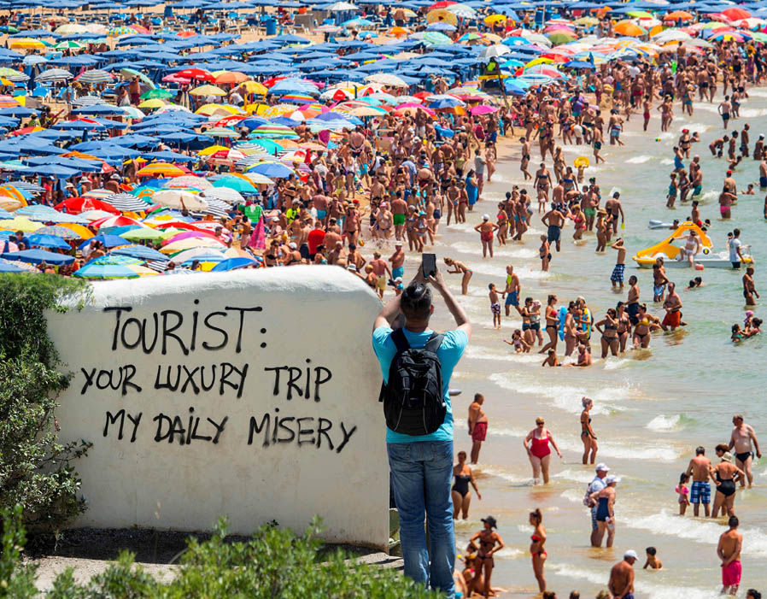

Unfortunately, there are still a lot of downsides such as environmental damage caused by pollution, destruction of habitats and forest fires. Also, there is often a lack of respect by tourists for local traditions and culture, f.e. by not following local dress standards, getting drunk in public, or behaving rudely or inappropriately towards locals. Therefore, the commercialization of culture can undermine the soul of a tourist destination. Due to over-tourism, residents find it increasingly difficult to find affordable housing and enjoy public spaces in Venice, Barcelona, Amsterdam – or indeed any major European city. Also, most of the tourism industry in a developing country is owned by big foreign companies. They make the major profits, leaving local businesses with relatively little benefit.

Conclusion

Some countries have taken measures to stop mass tourism. To contribute to the infrastructure and the natural environment, tourists must pay an additional tax before they enter countries such as Mexico, the United Kingdom or New Zealand. The Easter Islands have taken another measure by reducing the number of days tourists can stay from 90 to 30 days.

An alternative form of tourism is eco-tourism that takes special account of the needs of the environment and the local population. Over the past few decades, it has become its own market segment and is becoming more popular worldwide.